Bug Reports - error_user (SauceDemo)
This document outlines all defects identified during quality assurance testing on the SauceDemo application specifically for the error_user account profile.

BUG-01: [Products] Add to cart buttons do not respond for specific products
Attribute | Details
Bug ID | BUG-01
Module / Feature | Inventory / Products Page
Severity | High
Priority | High
Environment | Web - Chrome, Windows, SauceDemo Website

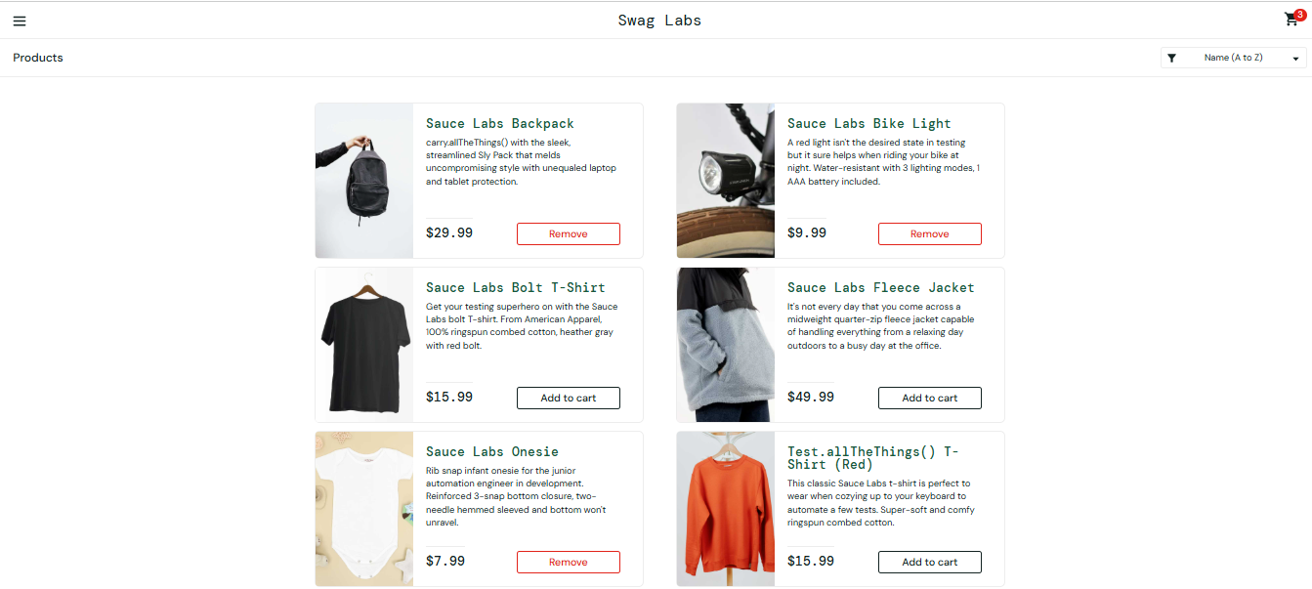

Description
Clicking "Add to cart" on Sauce Labs Bolt T-Shirt, Sauce Labs Fleece Jacket, or Test.allTheThings() T-Shirt (Red) is completely unresponsive. Button label remains "Add to cart" and cart counter does not update.

Related Test Cases
- Related TC: TC-17

Preconditions
- User is logged in as error_user.

Steps to Reproduce
- Open the SauceDemo website.
- Log in with username error_user and password secret_sauce.
- Click "Add to cart" on Sauce Labs Bolt T-Shirt, Sauce Labs Fleece Jacket, or Test.allTheThings() T-Shirt (Red).
- Check the cart badge icon at the top right.

Expected vs. Actual Results
Expected Result | Actual Result
Product is added to the shopping cart. | The "Add to cart" button does not respond to clicks.
The button label changes from "Add to cart" to "Remove". | The button label remains "Add to cart".
The shopping cart counter increments accordingly. | The item is not added to the cart, and the cart badge remains unchanged.

BUG-02: [Products] Remove buttons do not respond on the main Products page
Attribute | Details
Bug ID | BUG-02
Module / Feature | Inventory / Products Page
Severity | High
Priority | High
Environment | Web - Chrome, Windows, SauceDemo Website

Description
Clicking the "Remove" button for added products on the main catalog page fails to process item removal, leaving items stuck in cart.

Related Test Cases
- Related TC: TC-18

Preconditions
- User is logged in as error_user.
- Items are already added to the cart (e.g., Sauce Labs Backpack).

Steps to Reproduce
- Open the SauceDemo website.
- Log in with username error_user and password secret_sauce.
- Click "Add to cart" on Sauce Labs Backpack.
- Click the "Remove" button on the same product card on the Products page.

Expected vs. Actual Results
Expected Result | Actual Result
The item is removed from the shopping cart. | The "Remove" button does not respond to user interactions.
The button changes back to "Add to cart". | The item remains in the cart, and the button label stays as "Remove".
The cart badge counter decrements. | No changes occur on the cart badge.

BUG-03: [Product Details] Remove button fails inside the Product Details page
Attribute | Details
Bug ID | BUG-03
Module / Feature | Product Details Page
Severity | Medium
Priority | Medium
Environment | Web - Chrome, Windows, SauceDemo Website

Description
Attempting to remove an item inside its Product Details page using the "Remove" button fails to update cart state or button label.

Related Test Cases
- Related TC: TC-19

Preconditions
- User is logged in as error_user.
- An item is added to the cart.

Steps to Reproduce
- Log in with username error_user and password secret_sauce.
- Add Sauce Labs Backpack to the cart.
- Click on the title of Sauce Labs Backpack to open its details page.
- Click the "Remove" button inside the details page.

Expected vs. Actual Results
Expected Result | Actual Result
Item is removed from the cart, and the button label changes to "Add to cart". | Clicking "Remove" does not alter the cart state or button label.

BUG-04: [Products] Product sorting triggers an error popup and intermittent failure
Attribute | Details
Bug ID | BUG-04
Module / Feature | Inventory Sorting
Severity | High
Priority | High
Environment | Web - Chrome, Windows, SauceDemo Website

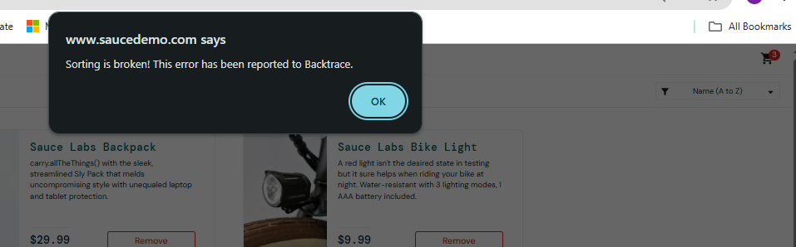

Description
Changing sort options repeatedly triggers explicit error alert: "Sorting is broken! This error has been reported to Backtrace."

Related Test Cases
- Related TC: TC-20

Preconditions
- User is logged in as error_user.

Steps to Reproduce
- Log in with username error_user and password secret_sauce.
- Click on the product sorting dropdown.
- Alternate between different sort options repeatedly.

Expected vs. Actual Results
Expected Result | Actual Result
Catalog re-orders smoothly without system exceptions or popup errors. | Sorting breaks and throws an explicit error alert stating "Sorting is broken!".

BUG-05: [Sidebar] "All Items" link logs user out with authorization error
Attribute | Details
Bug ID | BUG-05
Module / Feature | Navigation Sidebar
Severity | High
Priority | High
Environment | Web - Chrome, Windows, SauceDemo Website

Description
Clicking "All Items" in sidebar terminates session and redirects user to Login page displaying "Epic sadface: You can only access '/inventory.html' when you are logged in."

Related Test Cases
- Related TC: TC-21

Preconditions
- User is logged in as error_user.

Steps to Reproduce
- Open the sidebar navigation menu (3 horizontal lines).
- Click on the "All Items" link.

Expected vs. Actual Results
Expected Result | Actual Result
User stays on /inventory.html or is navigated back to the catalog without session disruption. | User is redirected to the login page with an error: "Epic sadface: You can only access '/inventory.html' when you are logged in."

BUG-06: [Sidebar] "Reset App State" button fails to clear cart or restore defaults
Attribute | Details
Bug ID | BUG-06
Module / Feature | Navigation Sidebar / System State
Severity | Medium
Priority | Medium
Environment | Web - Chrome, Windows, SauceDemo Website

Description
Clicking "Reset App State" does not reset UI state or clear shopping cart items.

Related Test Cases
- Related TC: TC-22

Preconditions
- User is logged in as error_user with items in the cart.

Steps to Reproduce
- Add items to the cart.
- Open the sidebar navigation menu.
- Click "Reset App State".

Expected vs. Actual Results
Expected Result | Actual Result
Cart badge is cleared, and all product buttons revert to "Add to cart". | Action is unresponsive; cart contents and app state remain unchanged.

BUG-07: [Checkout] System wipes Last Name input and shows validation error
Attribute | Details
Bug ID | BUG-07
Module / Feature | Checkout Step One (/checkout-step-one.html)
Severity | High
Priority | High
Environment | Web - Chrome, Windows, SauceDemo Website

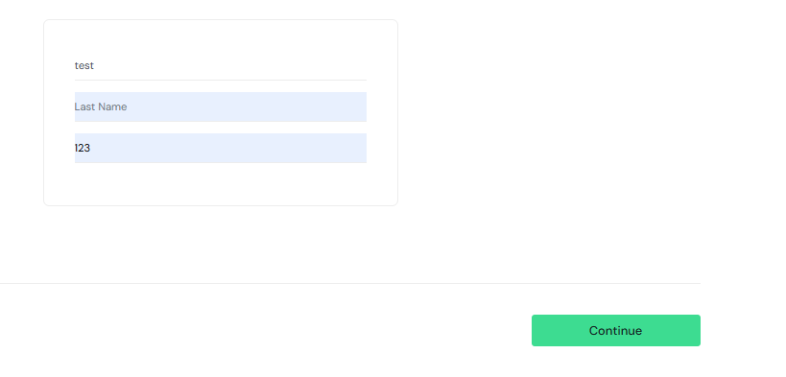

Description
Submitting valid Last Name in checkout step one results in the field being wiped upon clicking Continue, displaying "Error: Last Name is required".

Related Test Cases
- Related TC: TC-30 / TC-36

Preconditions
- User is logged in as error_user and is on /checkout-step-one.html.

Steps to Reproduce
- Enter First Name and Postal Code.
- Type or select a Last Name (e.g., "Osama").
- Click "Continue".

Expected vs. Actual Results
Expected Result | Actual Result
System accepts Last Name data and navigates to /checkout-step-two.html. | Last Name field is cleared, and validation error "Error: Last Name is required" is displayed.

BUG-08: [Checkout Overview] "Finish" button fails to complete the order
Attribute | Details
Bug ID | BUG-08
Module / Feature | Checkout Step Two (/checkout-step-two.html)
Severity | High
Priority | High
Environment | Web - Chrome, Windows, SauceDemo Website

Description
Clicking "Finish" button on Checkout Overview fails to finalize order or navigate to complete page.

Related Test Cases
- Related TC: TC-33

Preconditions
- User is logged in as error_user and on Checkout Overview.

Steps to Reproduce
- Proceed through checkout to /checkout-step-two.html.
- Click the "Finish" button.

Expected vs. Actual Results
Expected Result | Actual Result
User is navigated to /checkout-complete.html displaying the order confirmation message. | The button does not respond, and the user remains stuck on the overview page.

BUG-09: [Dynamic Catalog] Lazy Load, Spinner, and Slider options cause catalog item duplication and unexpected reloads
Attribute | Details
Bug ID | BUG-09
Module / Feature | Dynamic Catalog / Sidebar
Severity | Medium
Priority | Medium
Environment | Web - Chrome, Windows, SauceDemo Website

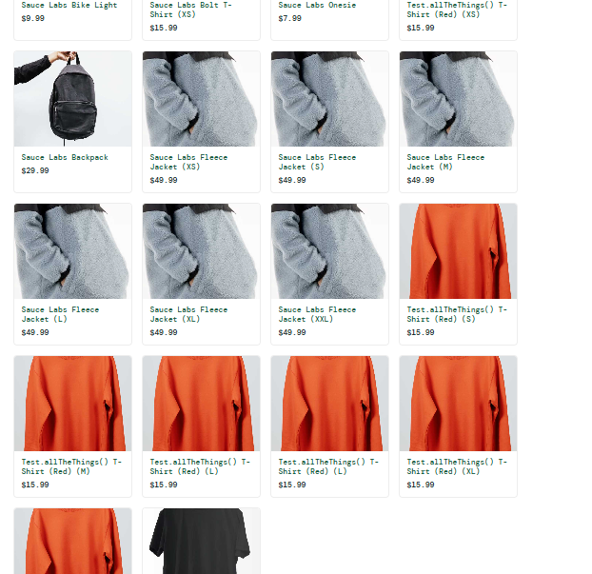

Description
Interacting with Dynamic Catalog options (Lazy Load, Spinner, Slider) duplicates catalog items excessively on screen instead of performing dynamic content fetching, and occasionally causes session resets.

Related Test Cases
- Related TC: TC-23 / TC-24

BUG-10: [Sidebar / Auth] Session error alert appears unexpectedly during menu navigation
Attribute | Details
Bug ID | BUG-10
Module / Feature | Navigation Sidebar / Authentication
Severity | High
Priority | High
Environment | Web - Chrome, Windows, SauceDemo Website

Description
Navigation within sidebar menu intermittently throws login requirement error dialog and logs out user completely to the main login screen.

Related Test Cases
- Related TC: TC-21

